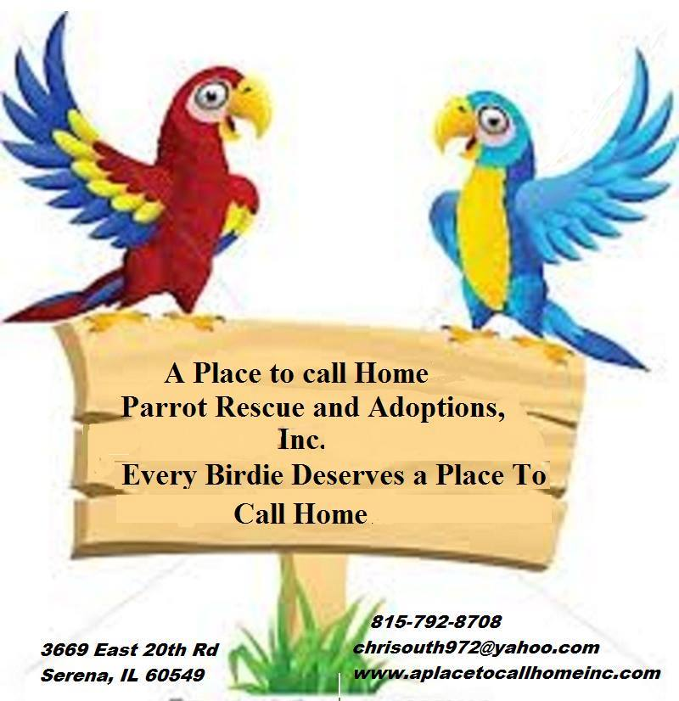
Scott & Christen Blaes Blaesin@yahoo.com
616 N. Harrison St 765.265.0490
Rushville, IN 46173

SURRENDER FORM

Name _____________________________ Species___________________________________________________
Age __________________ Unknown Hatch Date ___________________________________________ Unknown
Leg band: Y N Number ________________________ Sex: Male Female Unknown ____________________
Microchipped: Y N Unknown Company ______________________ Number ___________________________
Identifying Characteristics ________________________________________________________________________
Where was bird acquired _________________________________________________________________________
Former owners (if known) ________________________________________________________________________

Veterinary information:
Clinic Name ________________________________________ Doctor Name_______________________________
Address _____________________________________ City __________________ State _____ Zip _____________
Phone _______________________ Fax ________________________
Date of last checkup _____________________________
Does the bird have any known medical issues ________________________________________________________
_____________________________________________________________________________________________
_____________________________________________________________________________________________
_____________________________________________________________________________________________
_____________________________________________________________________________________________
Please provide copies of all available veterinary records and lists of medications the bird has taken _____________________________________________________________________________________________
_____________________________________________________________________________________________
_____________________________________________________________________________________________
A Typical Day in the Bird’s Life:
Morning Activities:
Approximate Time: Activity:
______________ ________________________________________________________________________
______________ ________________________________________________________________________
______________ ________________________________________________________________________
______________ ________________________________________________________________________
Afternoon Activities:
______________ ________________________________________________________________________
______________ ________________________________________________________________________
______________ ________________________________________________________________________
______________ ________________________________________________________________________
Early Evening Activities:
______________ ________________________________________________________________________
______________ ________________________________________________________________________
______________ ________________________________________________________________________
______________ ________________________________________________________________________
Bedtime Activities:
______________ ________________________________________________________________________
______________ ________________________________________________________________________
______________ ________________________________________________________________________
______________ ________________________________________________________________________
My Typical Feeding Routine:
My typical diet consists of __________________________________________________________________________________
________________________________________________________________________________________________________
________________________________________________________________________________________________________
________________________________________________________________________________________________________
Brand(s) of pelleted diet ____________________________________________________________________________________
________________________________________________________________________________________________________
________________________________________________________________________________________________________
Fruits and Veggies I like are (cooked or raw) ____________________________________________________________________
________________________________________________________________________________________________________
________________________________________________________________________________________________________
Other foods I enjoy ________________________________________________________________________________________
________________________________________________________________________________________________________
________________________________________________________________________________________________________
My favorite treat(s) is/are __________________________________________________________________________________
________________________________________________________________________________________________________
________________________________________________________________________________________________________
Drinking water preferences: Bottle Crock Other drinks ________________________________________________________
________________________________________________________________________________________________________
Time(s) of day I like to eat __________________________________________________________________________________
________________________________________________________________________________________________________
Food(s) that I think are yucky ________________________________________________________________________________
________________________________________________________________________________________________________
________________________________________________________________________________________________________
My Sleeping Habits:
I like to sleep ___________ hours a day.
I get sleepy around ___________ p.m. in the evening.
This is how I act when I’m tired ____________________________________________________________________
_____________________________________________________________________________________________
_____________________________________________________________________________________________
I know when it’s time for bed when you _____________________________________________________________
_____________________________________________________________________________________________
_____________________________________________________________________________________________
I like to be covered at bedtime: Y N
I like a nightlight on: Y N
I have night-frights: Y N Sometimes
Other things I want at bedtime ____________________________________________________________________
_____________________________________________________________________________________________
_____________________________________________________________________________________________
I wake up around ___________ a.m. in the morning.
This is my normal behavior in the morning ___________________________________________________________
_____________________________________________________________________________________________
_____________________________________________________________________________________________
_____________________________________________________________________________________________
_____________________________________________________________________________________________
Additional information __________________________________________________________________________
_____________________________________________________________________________________________
Other Helpful Things to Know About Me:
I am hand tame: Y N Other ___________________________________________________________________
I like to be with: Everyone / Women / Men / Children / Cats / Dogs / Other _______________ (circle all that apply)
Notes ________________________________________________________________________________________
I like to: Cuddle / Be Pet / Sit on Shoulders / Dance / Sing / Scream (circle all that apply)
Notes ________________________________________________________________________________________
_____________________________________________________________________________________________
____________________________________________________________________________________________
I like to get myself pretty by: Showers / Baths / Misting / Allowing you to preen me (circle all that apply)
Notes ________________________________________________________________________________________
_____________________________________________________________________________________________
These are a few things that I love __________________________________________________________________
_____________________________________________________________________________________________
_____________________________________________________________________________________________
These are a few things that I fear or dislike __________________________________________________________
_____________________________________________________________________________________________
_____________________________________________________________________________________________
I like to go outside: Y N Unsure
Here are (some of) the things that I can say __________________________________________________________
_____________________________________________________________________________________________
_____________________________________________________________________________________________
_____________________________________________________________________________________________
_

SIGN:______________________
DATE:___________

