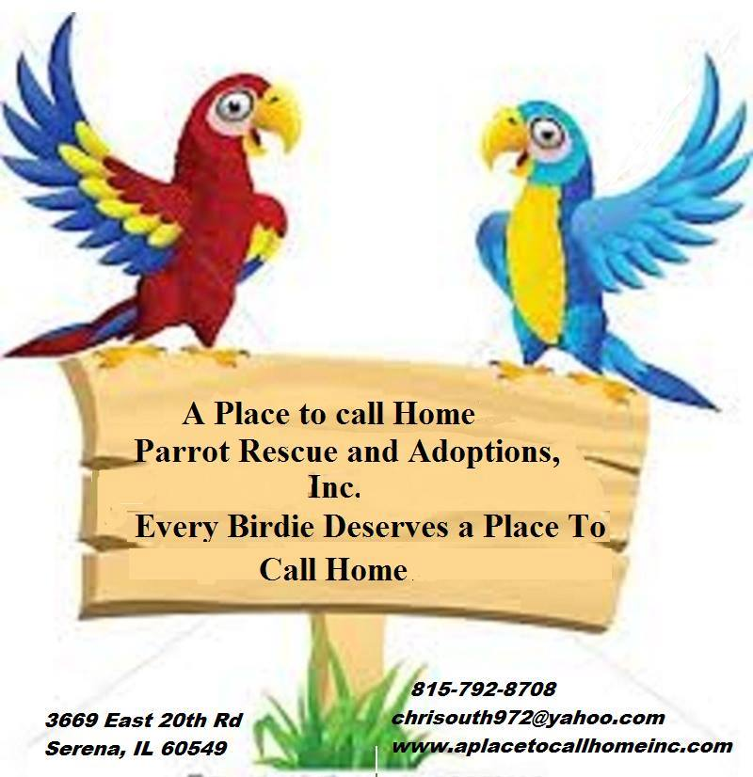

Scott & Christen Blaes Blaesin@yahoo.com

3418 East Everton Rd 765.265.0490

Connersville, IN 47331

ADOPTION CONTRACT

Bird’s Name ____________________ Sex: M F Unknown Species ____________________________________________

Leg Band Number ___________ Additional Description _________________________________________________________

Description of Veterinary Care Given __________________________________________________________________________

Microchipped: Y N Unknown __________________________________________________________________________

This Contract is entered into on the ___________ day of _____________________, 20____, by A Place to Call Home, Inc. Parrot Rescue and Adoption (“APTCH”) and _________________________________________________ (Adopter):

APTCH agrees to provide for the adoption of, and Adopter Agrees to adopt the bird described above according to the terms and conditions set forth herein:

**The bird you are adopting has been surrendered, abandoned, or in some way displaced. It may have been abused or neglected. There may only be limited, if any, information available regarding the bird’s previous environment. All available information and medical records have been provided to you. APTCH does not guarantee, nor is it responsible for the temperament or health of this bird, other than as is separately set forth in this Contract. There will be an adjustment period. Remember to be patient, consistent and understanding.**

1. Adopter agrees that this bird will NOT be used for breeding at any time under any circumstances. It also shall NOT be used for any illegal or unethical purpose.
2. Adopter agrees to accept this bird as a companion bird to live in Adopter’s home. Adopter agrees to provide this bird with proper food, water, veterinary care, and loving attention. Adopter agrees to keep this bird in a large cage and to provide the bird with adequate toys and perches. Adopter agrees to provide this bird with appropriate exercise for his/her species. Adopter agrees to obtain pertinent information regarding the proper care of this bird and to seek assistance from appropriate resources, including APTCH, as needed.
3. Adopter agrees to have this bird checked by a licensed veterinarian specializing in Avian medicine, within ten (10) days of adoption. If the veterinarian finds any life-threatening condition within ten (10) days of adoption that was present at the time of adoption, Adopter may return this bird to APTCH for a full refund of the adoption fee and any veterinary expenses that were incurred by the Adopter, excluding medication, during this ten (10) day period, provided that written documentation is furnished by the avian veterinarian, and provided that this bird is returned to APTCH no later than thirty (30) days after adoption. Adopter acknowledges and agrees that APTCH will NOT refund to Adopter any veterinary expenses paid to a veterinarian at any time after the ten (10) day period following the date of adoption.
4. Adopter understands that avian medicine is a relatively new discipline, and that it is possible for a bird to be a carrier of, or infected with, a disease that is undetectable using the current tests and tools available to avian veterinarians. APTCH is not responsible for any incidence of disease in the adopted bird detected or diagnosed more than ten (10) days after the adoption. APTCH is not responsible for any incidence of disease in other birds in Adopter’s home detected or diagnosed at any time after the adoption of a bird from APTCH. Adopter agrees to indemnify and hold APTCH harmless for any and all claims of any injury related to the adoption of the bird referred to in this Contract.
5. Adopter understands that it is his/her responsibility to quarantine any adoption bird brought into his/her home for not less than ninety (90) days, or as is recommended by the avian veterinarian treating the adoption bird. This quarantine period is for the protection of the adoption bird as well as the protection of any other birds in Adopter’s home. Adopter understands, however, that no period of quarantine can insure against the spread of any disease.
6. Adopter shall allow APTCH the right to examine and make inquiry about this bird in Adopter’s residence ***at any reasonable time***. If APTCH determines that there are deficiencies in the bird’s care, environment, disposition, health, or any other factors, the Adopter will receive a written document detailing these deficiencies and the required actions required to remedy the situation. APTCH will return to the residence of the Adopter after two (2) weeks time. If the Adopter is still not in compliance, the Adopter shall return the bird to APTCH with the APTCH representative performing the inquiry. Under these circumstances, the adoption fee is NOT refundable.
7. Adopter agrees that, ***if at any time*** Adopter is unable to keep this bird, Adopter shall contact APTCH for its sole determination as to the disposition of this bird. Adoption fees are NOT refundable under any circumstances, except as provided in paragraph 3 of this Adoption Contract.
8. Adopter agrees to notify APTCH of all home address, email address and phone number changes as well as any major changes in household situation.
9. If the bird is microchipped, the microchip is the property of APTCH unless explicitly stated otherwise in the top section of this Contract. If a bird carrying a microchip registered to APTCH is ever lost and then found by another party and subsequently scanned, APTCH will be notified. This is one of the many reasons it is imperative that APTCH be notified of all changes in home address, email address and phone number.
10. Adopter promises to comply with the laws and ordinances enforced in the state and municipality in which the Adopter resides.
11. Failure to comply with Paragraph Numbers 1, 2, 3, 6, 7, 8 and 10 of this Contract constitutes a breach of this Contract. Because damages caused by a breach of this Contract would be difficult to determine, the parties agree that the Adopter will pay APTCH the sum of $1,000 as liquidated damages and not as a penalty, for each and every breach of this contract.
12. The parties agree that the Payment Schedule, attached to the contract and marked as “Exhibit 1” shall be a material part of the Contract and legally binding on the Adopter.

Adoption Fee: $________________

Additional items: $________________

I would also like to make a tax-deductible donation in the amount of: $________________

Total: $________________

I, as the Adopter of this bird, certify that I have never been charged with or convicted of animal abuse or neglect in Illinois or in any other state. I certify that no one in the household where this bird will reside has been charged with or convicted of animal abuse or neglect in Illinois or in any other state. Initials: ________

**I have read this Contract and agree to be legally bound by its provisions.**

Adopter’s Signature _________________________________________________ Date ___________________________

Adopter’s Name (Print) _____________________________________________________________________________________

Address _____________________________________________ City _____________________ State _____ Zip ___________

E-mail ____________________________________________ Home # ____________________ Work # __________________

APTCH Representative Signature _________________________________________ Date ____________________________

Exhibit 1

Payment Schedule:

|  |  |  |  |
| --- | --- | --- | --- |
| Month | Date | Amount Due | Paid? |
|  |  |  |  |
|  |  |  |  |
|  |  |  |  |
|  |  |  |  |
|  |  |  |  |
|  |  |  |  |